Contents
Introduction to Java
Language Fundamentals

Java Features
- Simple / Ease of Development | - Portable
- Object Oriented | - Interpreted
- Distributed | - High Performance
- Robust | - Multithreaded
- Secure | - Dynamic
- Platform Independent | - Scalability and Performance
- Scalability and Performance | - Monitoring and Manageability
- Desktop Client | - JDBC RowSet

Java Terms
Terms | Description
JDK | Java Development Kit. It is super set and consists of Java Compiler, JRE, JVM.
JRE | Java Runtime Environment
JVM | Java Virtual Machine where the bytecode is executed.
Javac | Java compiler, which translates Java source code to bytecode files that the interpreter can understand.
Java | Java interpreter, which runs applets and application by reading and interpreting bytecode files. It is the launcher for Java applications. A single launcher is used both for development and deployment.
Java Code | Source code
Bytecode | Compiled Java code.

Running Java Program
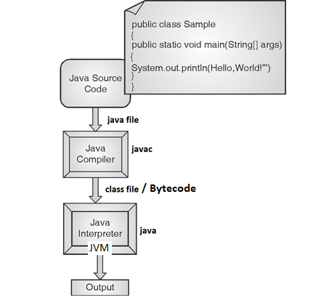
Program Structure
Documentation Section | Suggested
Package Statements | Optional
Import Statements | Optional
Interface Statements | Optional
Class Definitions | Optional
Main Method Class  {  Main Method Definition;  } | Essential

Types of Variables
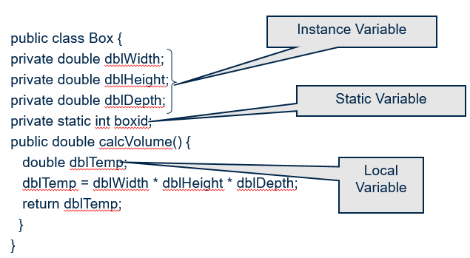
Instance variables : Instantiated for every object of the class
Static variables (Class Variables) : Not instantiated for every object of the class
Local variables : Declared in methods and blocks

Data Types
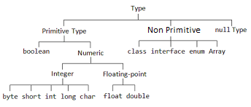

Special Operators
Operator | Example | Meaning
instanceof | parrot instanceof bird | TRUE if parrot object belongs to the class bird else it is FALSE.
dot operator(.) | parrot.beak | beak is the variable.
 | parrot.fly( ) | fly is the method.
new | bird parrot = new bird(); | The new operator is used to create object and arrays.

